How to Play Buggu Game:

1. Download Buggu Game
2. Locate Bug-Game

1. Extract Bug-Game

1. Locate main.html

1. Open main.html

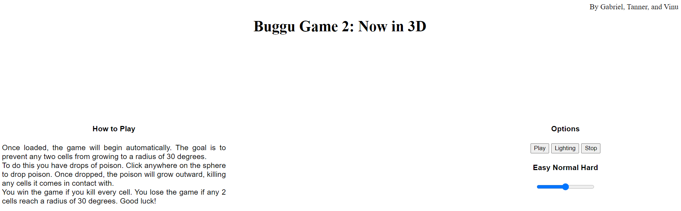

1. Read the how to play

1. Choose your difficulty, and press “Play”

1. Play Buggu Game 2

